Health and Safety and General Guidelines for Recorders

It is easy to be put off doing something due to the term “Health and Safety”. Please don’t be, it’s mostly common sense.
If you are going out to record please take the following into consideration beforehand.
- Certain native species are protected by law and it can be an offence even if you disturb them or a place they are using accidentally, equally you can cause an offence to release certain non-native species. Natural England provides guidance as to which species are protected and to what extent, see http://tinyurl.com/NEspecies.
A quick rule of thumb if you come across a badger, bat, dormouse, great crested newt, eel, native crayfish, otter, snake, water vole, or any nesting birds please do not disturb them, or their habitat. Leave them be and record where you spotted them – it will be a great help to them to be recorded!

Recording safely
Wherever possible do not survey alone. If you have to, make sure someone knows where you are going and when you expect to be back.

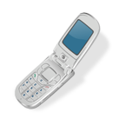
Make sure both of you have a charged mobile phone that is on and has reception. If there is no reception, know where your nearest working phone box/house is to go for help in an emergency.
Wear suitable clothing and footwear for the weather conditions.
When surveying be particularly aware of slippery or uneven surfaces and low branches or holes, a simple walking stick is a great help when surveying.

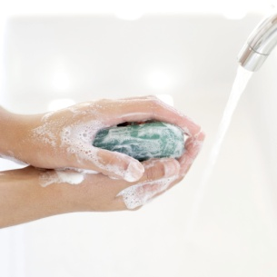
To further reduce the small chance of catching Weil’s disease when working around water make sure you wash hands thoroughly before eating, drinking or smoking. If you do feel ill and experience flu-like symptoms a few days/weeks after, do consult a doctor and
ask for an Elisa Blood test.

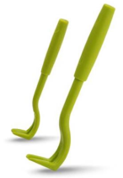
Check your clothing and skin for ticks, particularly if walking through long vegetation on dry days as some ticks carry Lyme’s disease (the NHS provides good detail http://www.nhs.uk/Conditions/Lyme-disease/Pages/Introduction.aspx). If you find one, do not pull it off, flick it, burn it, put alcohol on it etc. Either buy a cheap tick remover http://www.ticktwister.co.uk/tick-remover-people.html (Amazon also sell them) or go to your local chemist or GP to help remove it. They need to be carefully removed to reduce any chance of getting the disease. If you think you may have caught the disease, please see your GP.

Beware of Giant Hogweed; it can cause severe skin irritation.


Particularly in very hot weather, make sure you carry plenty of water and suncream with you.

When surveying along drainage ditches (with water):
- You must survey in pairs and know a third person you can contact in case of emergency, it is very easy to slip along some of the drainage banks and without help, it may be impossible to get out.
- You must be able to swim at least 50m comfortably.
- You must have a walking stick, hiking pole or throw line with you to help pull you out if needed – if you’re stood on the bank always shout first to the person to come to the bank.
Disclaimer
Please note these are only guidelines, CPERC are not responsible for any accidents that occur.

